Nikunj Bhalotia
Abstract
This report presents the security assessment of Altoro Mutual’s online banking application, pointing out the key vulnerabilities, regulatory compliance gaps, and prioritised recommendations for risk mitigation.
Altoro Mutual
Security Assessment and Audit Report

Table of Contents
1.0 Document Control 3
1.1 Identity 3
1.2 History 3
1.3 Distribution List 3
1.4 Principal Contact 3
1.5 Document Purpose 3
2.0 Introduction 4
2.1 Assessment Purpose 4
2.2 Scope of Work 4
2.3 Vulnerability Mapping, Threat Modelling and Risk Rating Methodology 4
2.4 Limitations Encountered 5
3.0 Summary of Work Carried out 6
3.1 Activities Undertaken 6
3.2 Key Outcomes 6
4.0 Assessment Findings 7
4.1 Overview 7
4.2 Business Impact 8
4.3 Findings Distribution 9
4.4 Vulnerability details 10
4.4.1 A01-2021: Broken Access Control 10
4.4.2 A02-2021: Cryptographic Failures 11
4.4.3 A03-2021: Injection 11
4.4.4 A04-2021: Insecure Design 12
4.4.5 A05-2021: Security Misconfiguration 12
4.4.6 A06-2021: Vulnerable and Outdated Components 13
4.4.7 A07-2021: Identification and Authentication Failures 13
4.4.8 A08-2021: Software and Data Integrity Failures 14
4.4.9 A09-2021: Security Logging and Monitoring Failures 14
4.4.10 A10-2021: Server-Side Request Forgery (SSRF) 15
5.0 Security and compliance standards evaluation 16
5.1 General Data Protection Regulation (GDPR) compliance mapping 16
5.2 PCI-DSS Compliance Mapping 18
6.0 Remediation Recommendation 20
6.1 Critical Priority (Immediate Action Required) 20
6.2 High Priority (Remediate within Short Term) 20
6.3 Medium Priority (Plan Remediation in Medium Term) 21
6.4 Low Priority (Continuous Improvement) 21
7.0 Conclusion 22
8.0 References 23

Document Control

Identity
File Information
Issue Type | Draft
Issue Date | 4th Spetember 2025
Current Version | 1.0
File Name | Altoro Mutual Website Vulnerability Assessment Report V1.0.docx

History
Version | Author | Date | Revision Notes
D 0.1 | Nikunj Bhalotia | 19th August 2025 | Document Installation
D 0.2 | Nikunj Bhalotia | 25th August 2025 | Revision One
P 1.0 | Nikunj Bhalotia | 4th September 2025 | Final Version

Distribution List
Name | Role | Company | Email Address
John Doe | Chief Information Security Officer | Altoro Mutual | John.doe@demo.testfire.net
Jane Doe | Head of Development | Altoro Mutual | Jane.doe@demo.testfire.net

Principal Contact
Name | Role | Company | Email Address
Nikunj Bhalotia | Principal Consultant | Nikunj Bhalotia Inc | nikunj@nikunjb.com

Document Purpose
This report presents the security assessment of Altoro Mutual’s online banking application, pointing out the key vulnerabilities, regulatory compliance gaps, and prioritised recommendations for risk mitigation.

Introduction

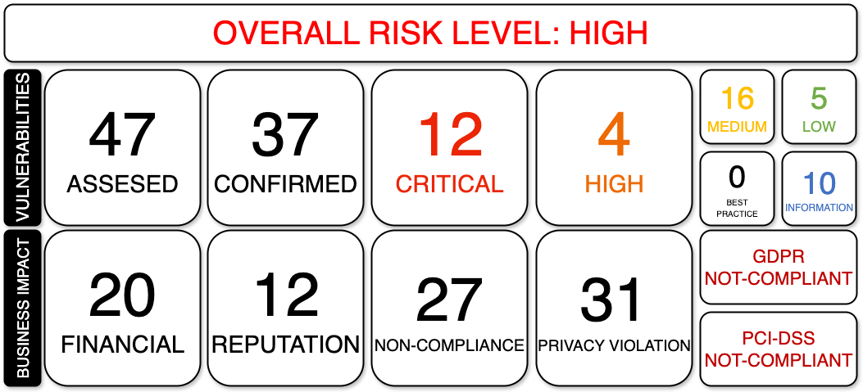

Assessment Purpose
The assessment was conducted to evaluate Altoro Mutual’s online banking website (demo.testfire.net) using the banking industry standards. The purpose of the evaluation was to identify vulnerabilities which could pose a substantial business impact to Altoro Mutual. It assessed these against regulatory frameworks and provided prioritised recommendations to reduce risks.

Scope of Work
The following items were in scope:
- Web application (https://demo.testfire.net).
- Associated API endpoints.
- Source code and configuration review.
- Compliance checks against GDPR, PCI-DSS, and FFIEC guidelines.
The following were excluded:
- Internal corporate networks and employee devices.
- Third-party integrated services are not under Altoro Mutual’s control.
- Social engineering

Vulnerability Mapping, Threat Modelling and Risk Rating Methodology
The assessment was carried out using the OWASP Top 10 (2021) and the OWASP Web Security Testing Guide (WSTG) (OWASP,2021; OWASP,2023). A combination of automated tools (e.g., Burp Suite, OWASP ZAP, Dependency-Check, testssl.sh) and manual validation was used to test for vulnerabilities across access controls, injection flaws, cryptographic implementations, insecure design, misconfiguration, outdated components, and logging/monitoring weaknesses.
Risks were evaluated using the OWASP Risk Rating Methodology (OWASP, n.d.). This methodology guides the evaluation of the impact that the vulnerability can cause against the probability of the breach, to classify findings into different severities (Critical, High, Medium, Low, and Informational). This approach ensured that findings were prioritised in a manner aligned with business impact.

Limitations Encountered
During the assessment, the following limitations were encountered:
- Testing was limited to the public web environment; internal infrastructure and production networks were excluded.
- No social engineering or denial-of-service tests were performed to avoid operational disruption.
- As automated scans can sometimes generate false positives, to mitigate this, manual verification was applied to confirm critical issues.
- Specific findings (e.g., insecure design flaws, SSRF) required runtime testing in a production environment, which was unavailable during the engagement.
- The three-week testing window constrained the depth of review for some complex business logic vulnerabilities.

3.0 Summary of Work Carried out
The security assessment of Altoro Mutual’s online banking platform was carried out over three weeks, combining automated vulnerability scanning, manual penetration testing, and static code/configuration review.

Activities Undertaken
Below is the summary of the activities that were conducted:
- Automated Scanning was carried out using Burp Suite and OWASP ZAP to identify injection flaws, authentication weaknesses, and cross-site scripting (XSS) issues. Dependency-Check was employed to detect outdated or vulnerable third-party components.
- Findings were manually confirmed to eliminate false positives and to assess the potential business impact. Focus was placed on access control mechanisms, cryptographic implementations, and business logic flaws such as workflow bypasses and insecure password reset processes.
- Analysis of web server and application configurations was undertaken to identify verbose error messages, insecure headers, and missing transport-layer protections.
- Source code was reviewed for insecure design decisions, hardcoded credentials, weak session handling, and insufficient input validation.
- Findings were mapped against the General Data Protection Regulation (GDPR) (Articles 25, 32, 33, and 34) and PCI-DSS v4.0 requirements (Requirements 3, 4, 6, 7, 8, and 10).

Key Outcomes
Below are the key outcomes of the activities conducted:
- A total of 47 security findings were identified across all OWASP Top 10 categories.
- Findings were risk-rated using the OWASP methodology: 9 Critical, 7 High, 14 Medium, 2 Low, and 15 Informational (Note).
- The most severe issues related to broken access control, SQL injection, cryptographic failures, insecure design, and lack of logging and monitoring.
- Several findings indicated regulatory non-compliance, including clear-text transmission of credentials (GDPR Article 32 and PCI-DSS Requirement 4), weak authentication controls (GDPR Article 25 and PCI-DSS Requirement 8), and insufficient monitoring/logging (GDPR Articles 33–34 and PCI-DSS Requirement 10).
- Some tests, particularly those concerning SSRF (Server-Side Request Forgery) and certain misconfigurations, were flagged as “not verified” due to environment constraints.

Assessment Findings

Overview
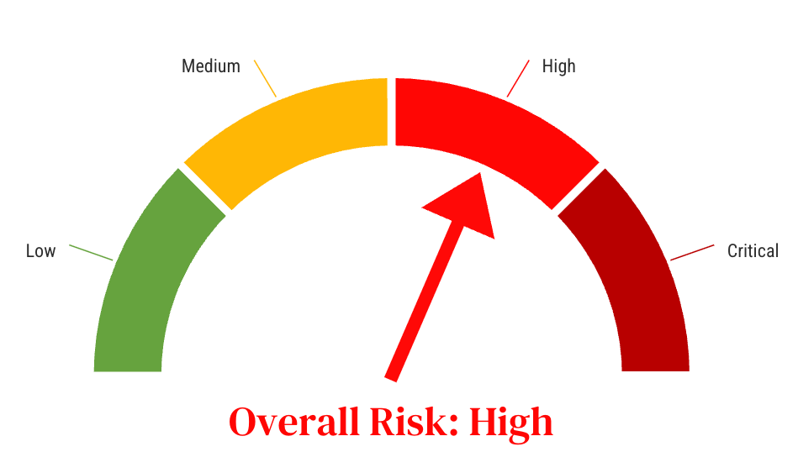
The assessment identified 47 security issues across Altoro Mutual’s online banking platform. These findings were evaluated using the OWASP Risk Rating Methodology, which considers both the impact of exploitation and the likelihood of occurrence.
The charts below summarise the severity and distribution of findings.
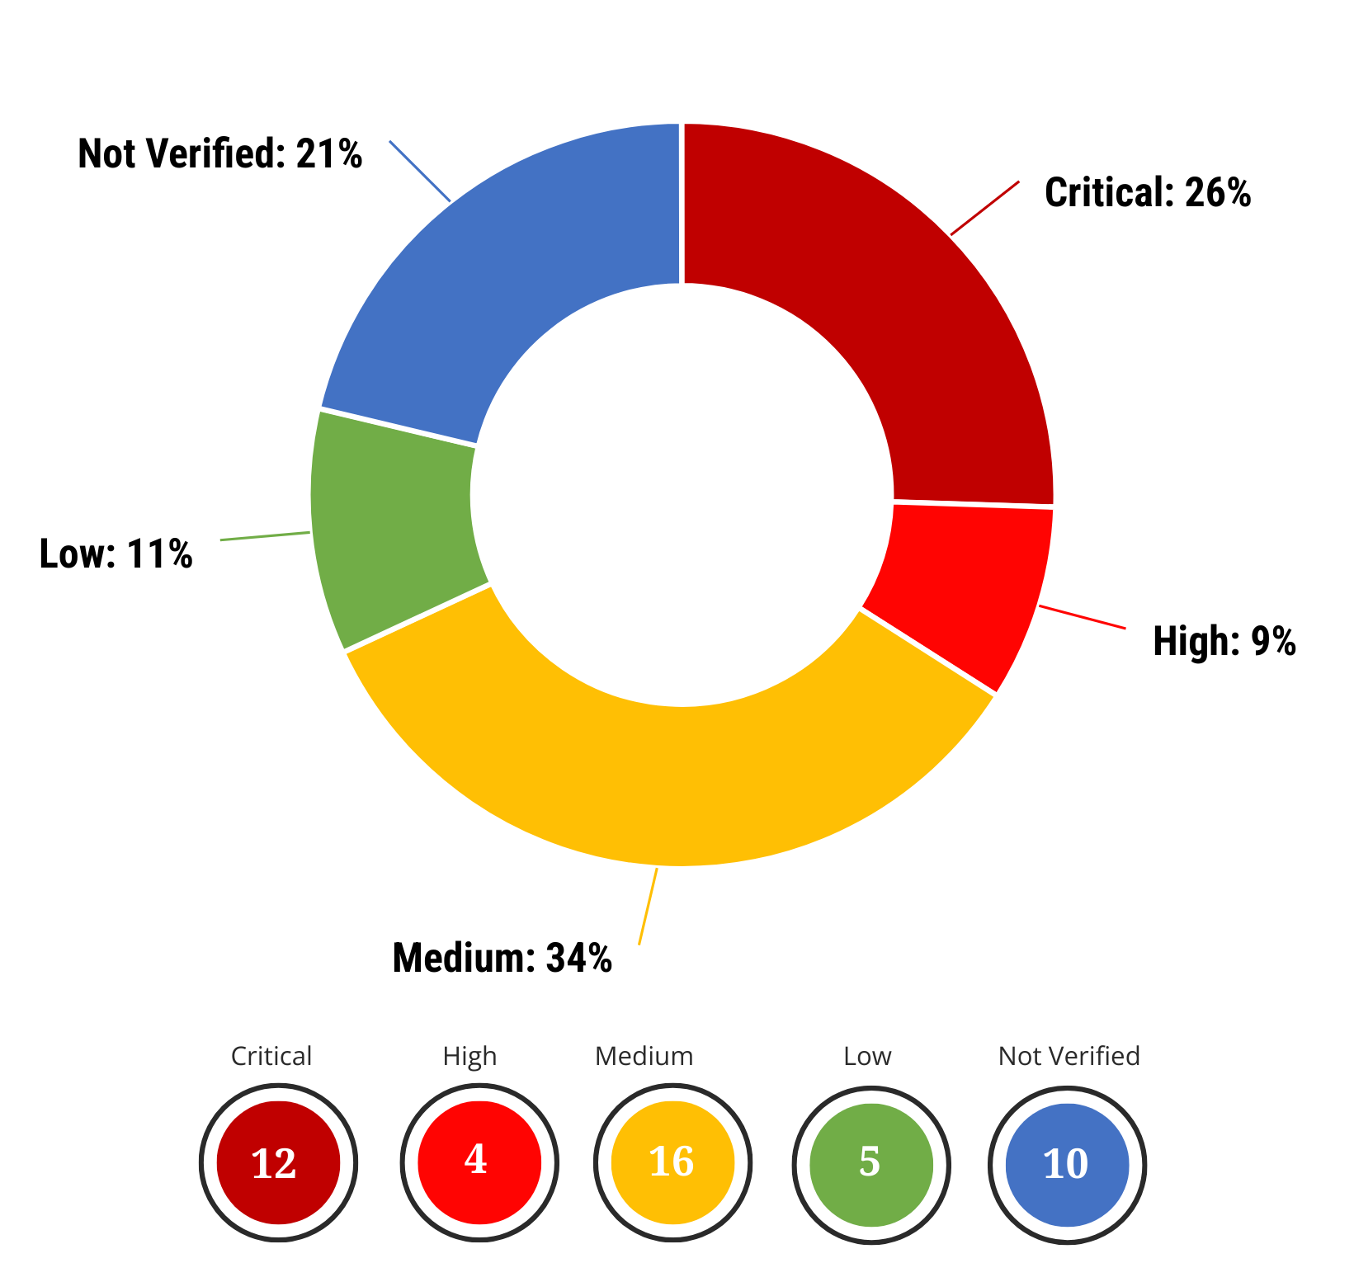
This distribution indicates that nearly 34% of findings fall into the Critical or High category, representing a significant risk to the confidentiality, integrity, and availability of customer and business data.

Business Impact
The vulnerabilities identified were mapped to four main business impact categories: Financial Damage, Reputational Damage, Non-Compliance, and Privacy Violation (OWASP, 2021). These categories show how weaknesses in the application can directly affect customers and the organisation. The table below depicts the number of vulnerabilities that fall into each business impact category.
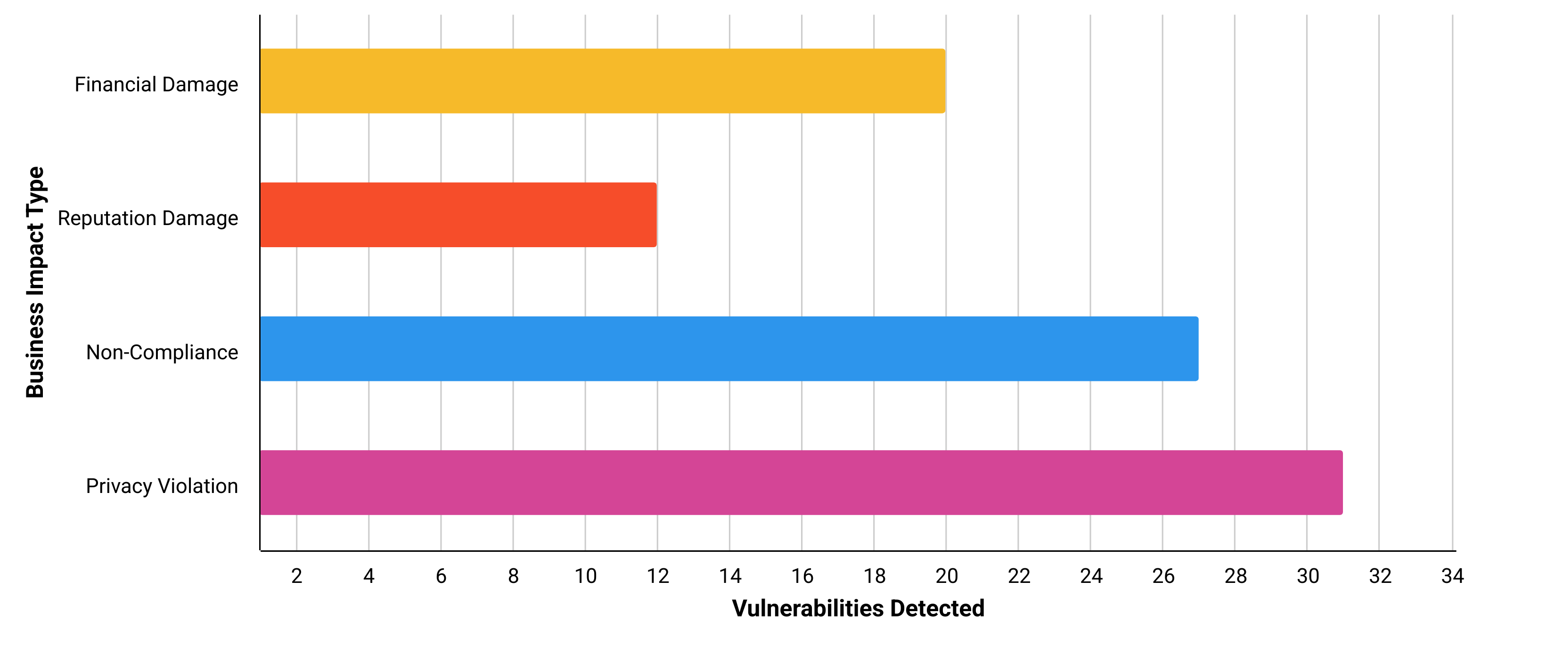
Financial Damage: Weak access controls and injection flaws could enable fraudulent transactions or the manipulation of account balances, resulting in direct monetary losses for both customers and the bank.
Reputational Damage: Public disclosure or exploitation of vulnerabilities would erode customer confidence and damage the bank’s credibility, potentially resulting in customer attrition.
Non-Compliance: Several findings indicate a misalignment with GDPR and PCI-DSS requirements, exposing the institution to regulatory fines, legal consequences, and increased scrutiny.
Privacy Violation: Insecure handling of credentials and personal data increases the risk of account takeover and identity theft, undermining customer trust and triggering data breach obligations.
Collectively, these impacts place Altoro Mutual at high risk of financial, regulatory, and reputational harm.

Findings Distribution
The distribution of vulnerabilities across the OWASP Top 10 categories provides clear insight into where the application is most exposed. By classifying findings by severity within each category, it becomes evident that weaknesses are not evenly spread but instead concentrate in specific high-risk areas.

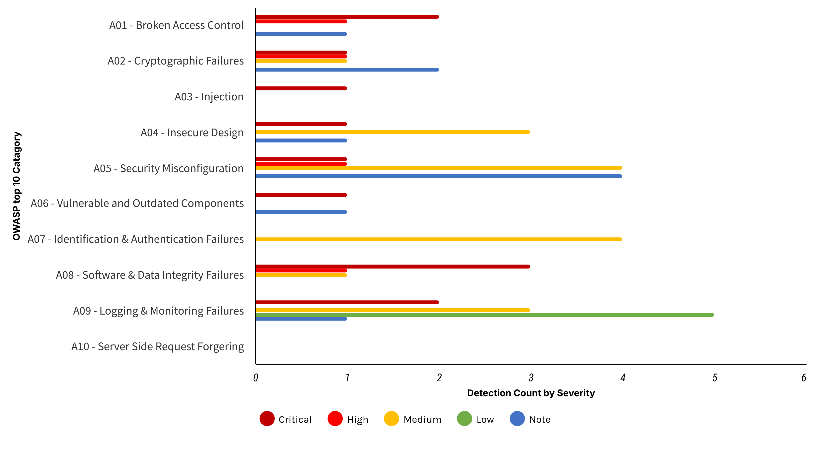
The analysis identifies Security Misconfiguration (A05), Software & Data Integrity Failures (A08), and Logging & Monitoring Failures (A09) as the primary concerns. These issues significantly raise the risk of exploitation and data breaches. Therefore, prioritising the correction of misconfigurations, enhancing monitoring, and enforcing integrity measures should be top remediation goals. Additionally, medium and low-level issues in other categories should also be addressed to improve the overall security posture.

Vulnerability details
This section details the vulnerabilities and gaps identified in each of the OWASP Top 10 categories

A01-2021: Broken Access Control
Broken access control occurs when apps fail to enforce restrictions on authenticated users, resulting in unauthorised access. In Altoro Mutual, several cases revealed access validation errors, which posed a risk to critical features.
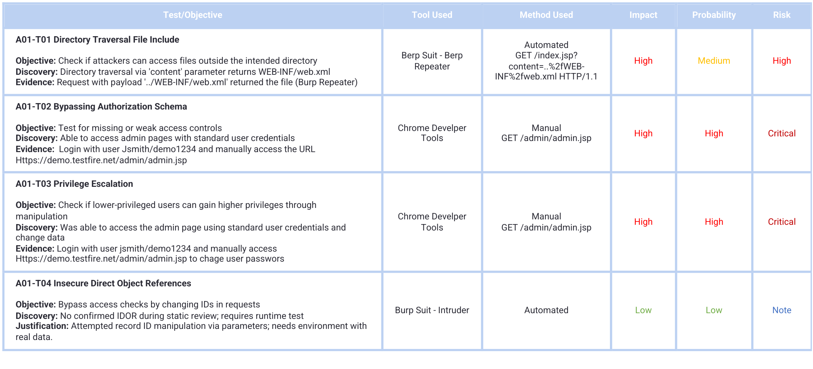

A02-2021: Cryptographic Failures
Cryptographic failures (previously “Sensitive Data Exposure”) occur when applications do not protect data in transit or at rest. On Altoro Mutual’s website, clear-text transmission, weak transport layer security and the use of outdated encryption algorithms were identified, putting sensitive information and data at risk.
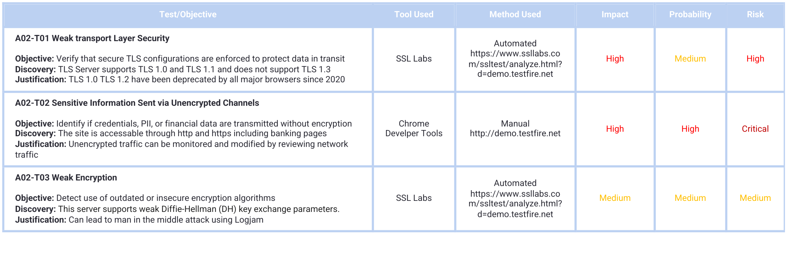

A03-2021: Injection
Injection flaws occur when untrusted data is sent to an interpreter as part of a command or query. Attackers can trick the interpreter into executing unintended commands or accessing unauthorized data. In Altoro Mutual, SQL Injection vulnerabilities were confirmed, while Command Injection and ORM Injection require further dynamic validation.
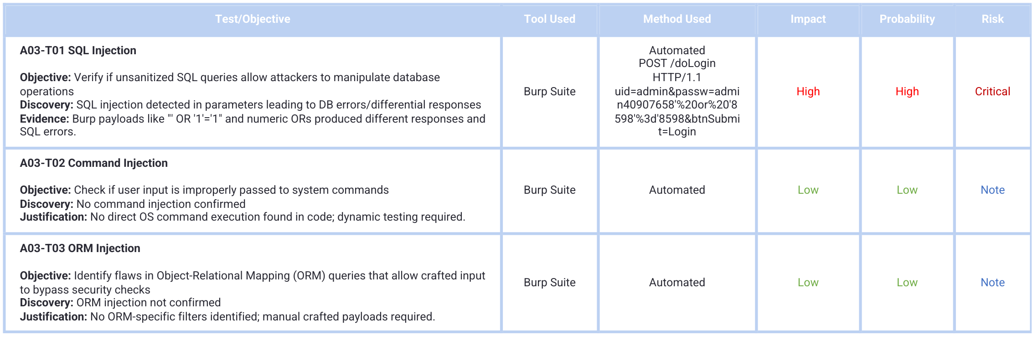

A04-2021: Insecure Design
Insecure design reflects weaknesses in application architecture and business logic rather than implementation bugs. Altoro Mutual exhibits multiple insecure design flaws, including missing workflow validation, weak authentication design, and insufficient enforcement of security controls. These gaps create systemic risks even when individual code modules appear correct.
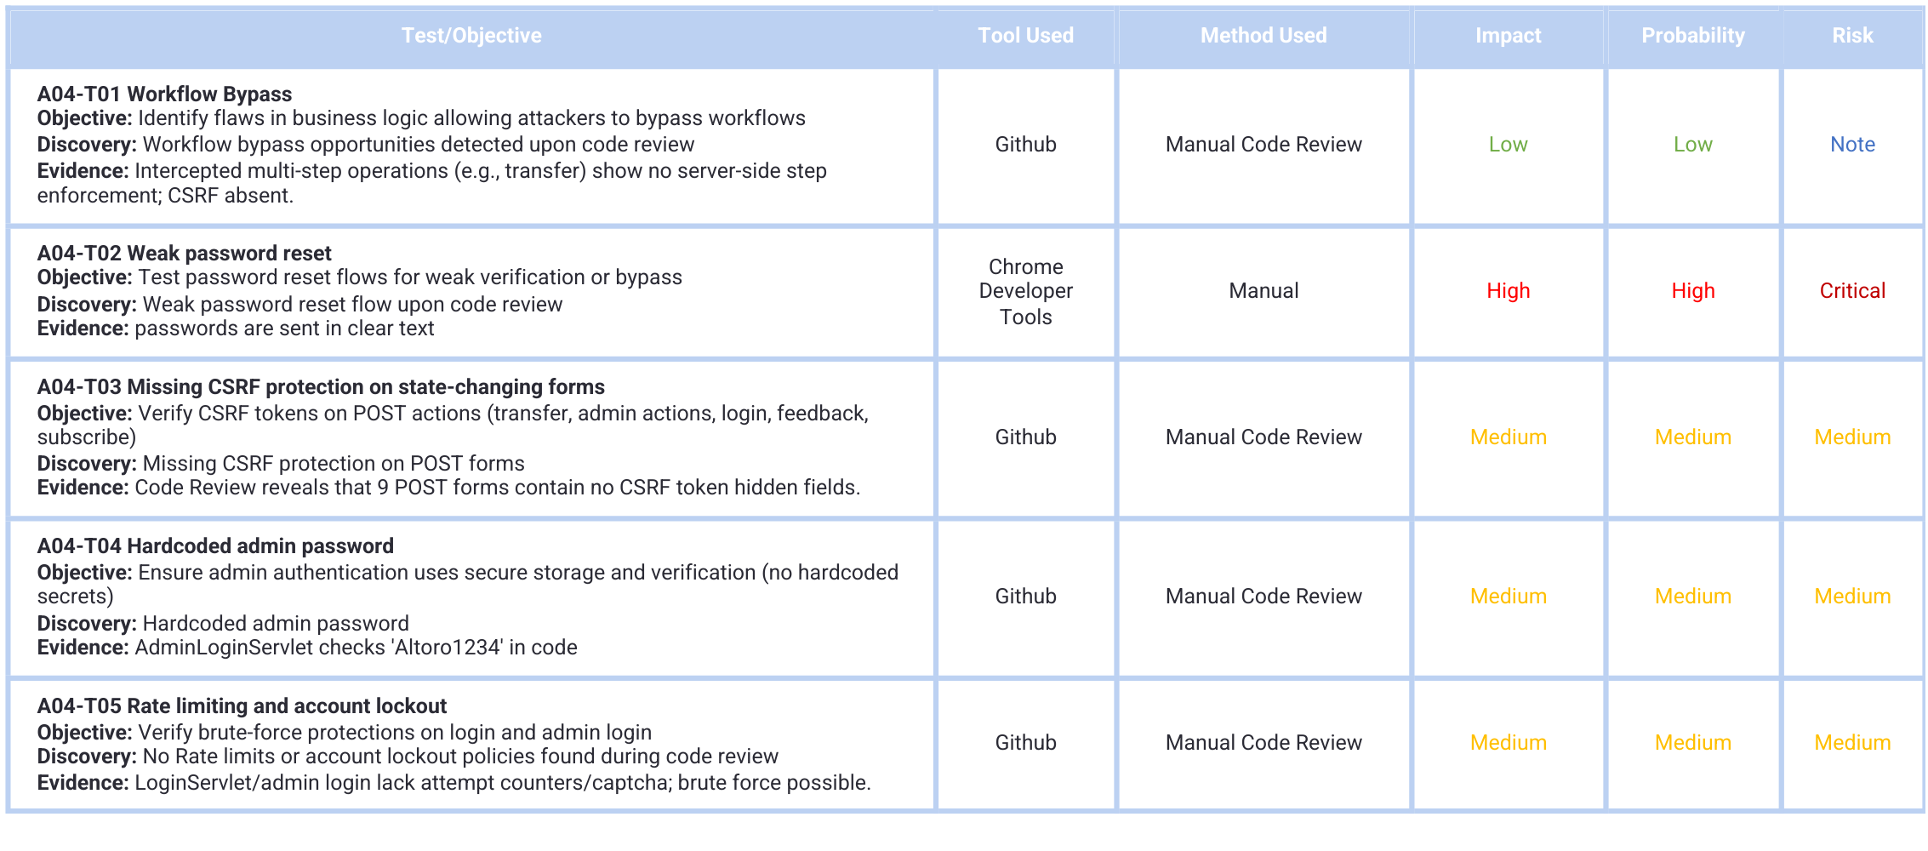

A05-2021: Security Misconfiguration
Security misconfiguration is one of the most common issues in web applications. It occurs when security settings are missing, default, or poorly implemented, leaving the system open to exploitation. In Altoro Mutual, multiple misconfigurations were identified at the platform, application, and HTTP header level.
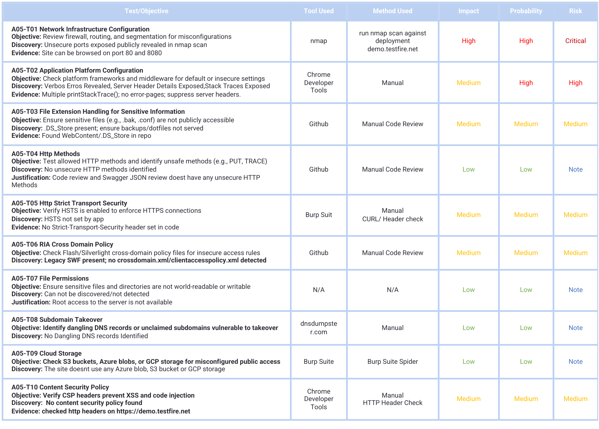

A06-2021: Vulnerable and Outdated Components
Applications often rely on third-party frameworks, libraries, and platforms. When these components are outdated or unpatched, attackers can exploit known vulnerabilities to compromise the system. Dependency-Check revealed outdated dependencies in Altoro Mutual (e.g., Struts/Spring) that map to known CVEs.
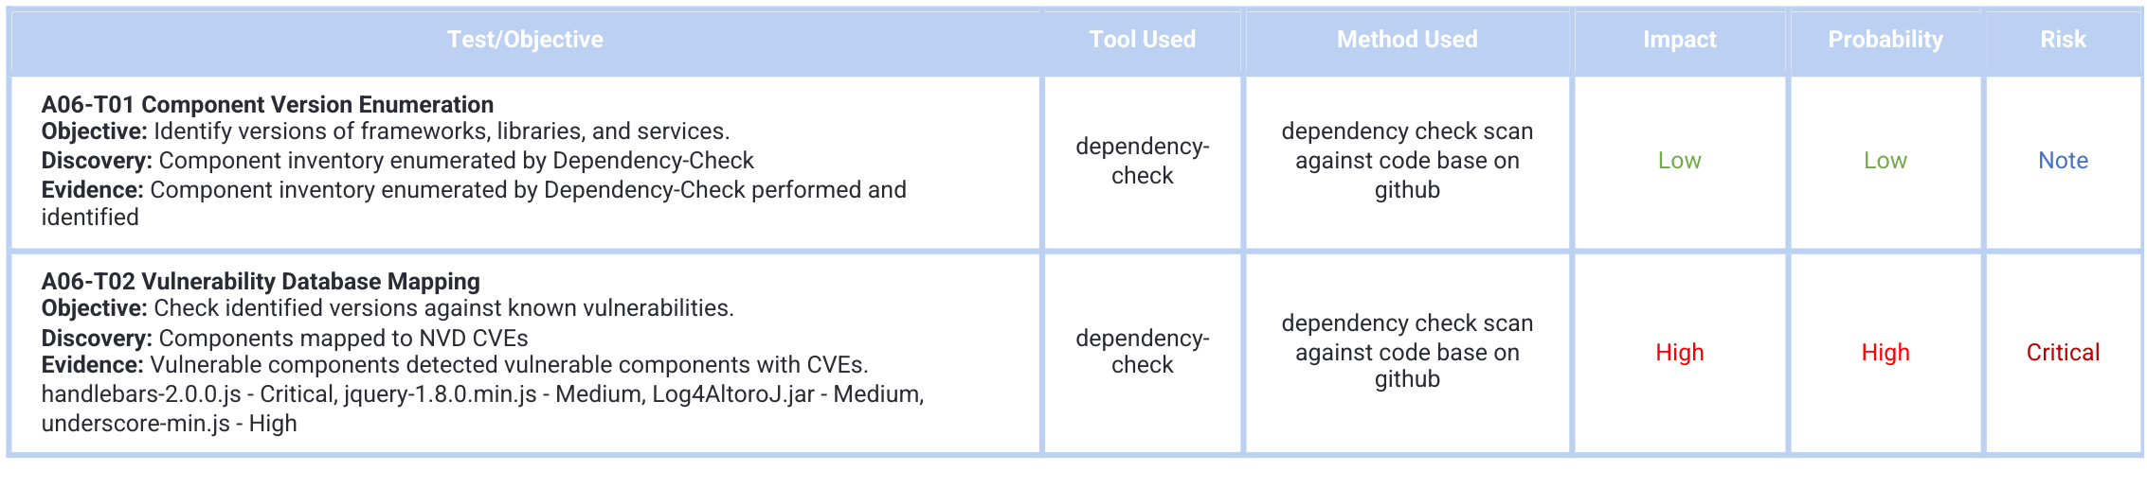

A07-2021: Identification and Authentication Failures
Identification and authentication failures occur when applications improperly implement or enforce user identity and authentication controls. In Altoro Mutual, issues include weak validation in registration, poor error handling, unenforced username policies, and reliance on filters instead of container-managed security, exposing the application to account takeover and brute-force attacks
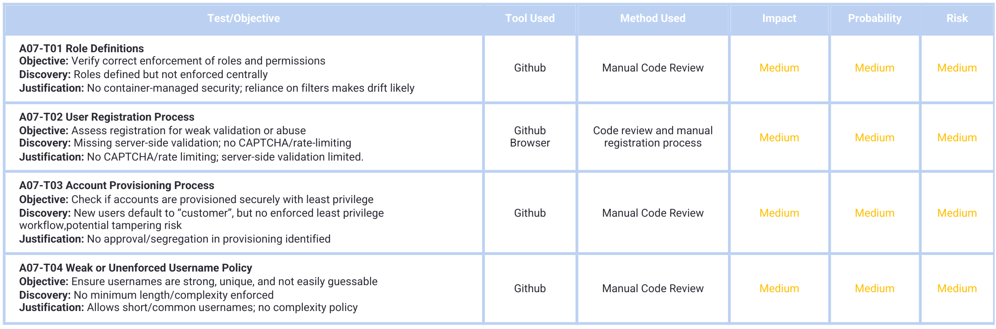

A08-2021: Software and Data Integrity Failures
Software and data integrity failures occur when code, updates, and critical data lack integrity verification mechanisms. This exposes applications to malicious code injection, supply chain attacks, and tampering. In Altoro Mutual, issues were identified in patch validation, CI/CD practices, input validation, and dependency management
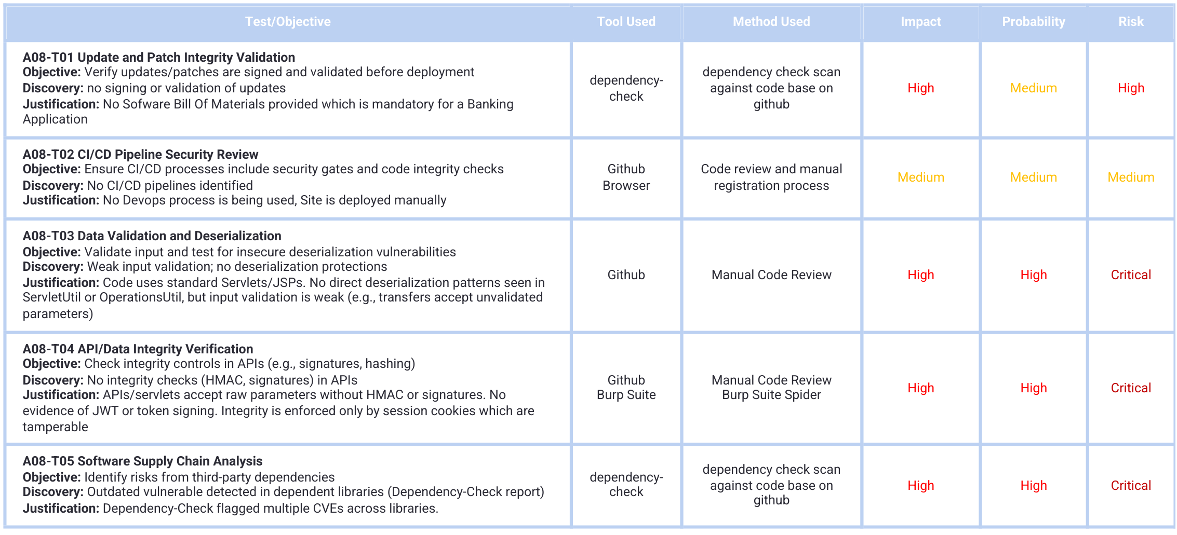

A09-2021: Security Logging and Monitoring Failures
Logging and monitoring failures occur when security-critical events are not logged, logs are incomplete or tamperable, and alerting mechanisms are absent. In Altoro Mutual, the absence of structured logs, real-time monitoring, and audit trails significantly increases the likelihood of undetected breaches.
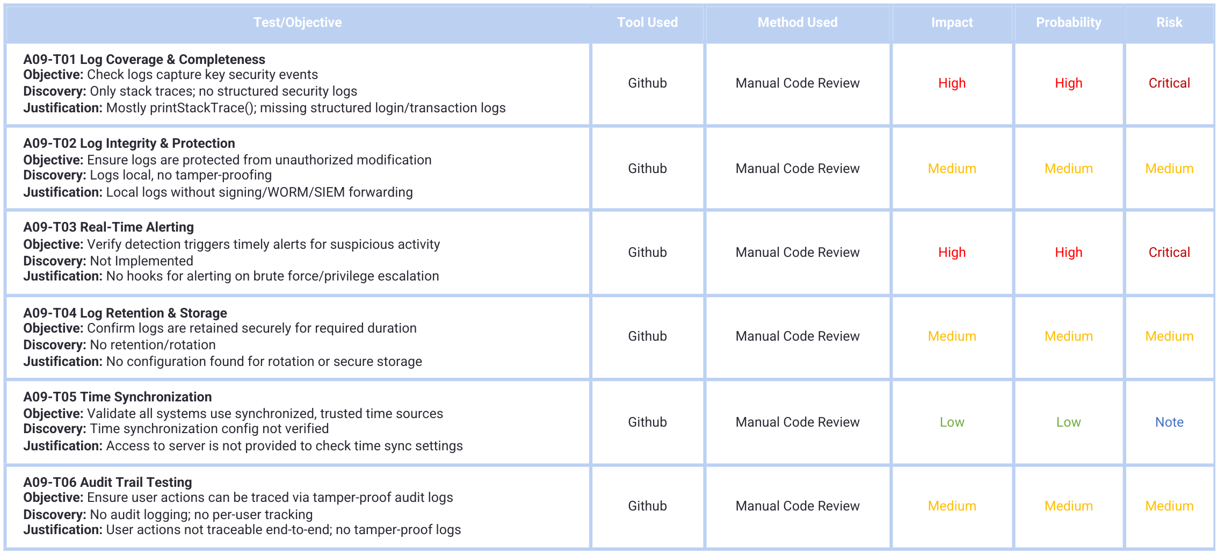

A10-2021: Server-Side Request Forgery (SSRF)
SSRF vulnerabilities occur when a web application fetches a remote resource without proper validation of user-supplied URLs. This enables attackers to force the server to make requests to internal systems or external malicious services. In Altoro Mutual, no direct SSRF sinks were identified in code review, but runtime testing is required to validate cloud metadata access, protocol smuggling, and blind SSRF vectors.
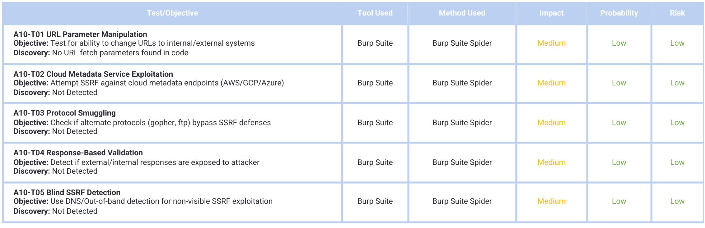

Security and compliance standards evaluation
The assessment not only identified technical vulnerabilities but also evaluated Altoro Mutual’s online banking platform against essential regulatory and industry standards. It concentrated on the GDPR and PCI-DSS, which specify required controls to safeguard sensitive financial and personal information. The analysis below highlights areas of non-compliance, illustrating how the findings align with specific regulatory requirements.

General Data Protection Regulation (GDPR) compliance mapping
The GDPR establishes stringent requirements for the protection of personal data, with particular emphasis on data confidentiality, integrity, availability, and accountability (Europian Eunion, 2016). The assessment identified multiple areas where Altoro Mutual’s website failed to meet these obligations. The table below maps the gaps identified in the evaluation against the guidance provided by the applicable GDPR Articles.

GDPR Article | Obligation Summary | Test ID | Finding | Notes
Article 33: Security of processing | Ensure confidentiality, integrity and availability via appropriate technical and organisational measures. | A01-T01 | Directory Traversal (File Include) | Unauthorized file access compromises confidentiality of personal/system data.
Article 25: Data protection by design and by default & Article 32: Security of processing | Build and operate systems with privacy-by-design; apply least privilege and secure defaults. | Ensure confidentiality, integrity and availability via appropriate technical and organisational measures. | A01-T02 | Bypassing Authorization Schema | Access control bypass undermines least privilege and secure processing.
Article 25: Data protection by design and by default & Article 32: Security of processing | Build and operate systems with privacy-by-design; apply least privilege and secure defaults. | Ensure confidentiality, integrity and availability via appropriate technical and organisational measures. | A01-T03 | Privilege Escalation | Weak admin authentication and missing MFA allow unauthorized high-privilege actions.
Article 32: Security of processing | Ensure confidentiality, integrity and availability via appropriate technical and organisational measures. | A02-T01 | Weak Transport Layer Security | Insufficient TLS configuration risks interception/tampering of personal data in transit.
Article 32: Security of processing & Article 34: Communication of a personal data breach to the data subject | Ensure confidentiality, integrity and availability via appropriate technical and organisational measures. | Inform affected individuals without undue delay if a breach is likely to result in high risk. | A02-T02 | Cleartext Password Transmission | Credentials submitted over HTTP; likely to trigger breach obligations if intercepted.
Article 32: Security of processing | Ensure confidentiality, integrity and availability via appropriate technical and organisational measures. | A02-T03 | Weak Encryption | Use of deprecated/weak algorithms jeopardises confidentiality/integrity.
Article 32: Security of processing | Ensure confidentiality, integrity and availability via appropriate technical and organisational measures. | A03-T01 | SQL Injection | Exploitation may read/modify personal/financial data in backend databases.
Article 25: Data protection by design and by default & Article 32: Security of processing | Build and operate systems with privacy-by-design; apply least privilege and secure defaults. | Ensure confidentiality, integrity and availability via appropriate technical and organisational measures. | A04-T01 | Workflow Bypass | Missing server-side enforcement enables unauthorized business operations.
Article 32: Security of processing | Ensure confidentiality, integrity and availability via appropriate technical and organisational measures. | A04-T04 | Missing CSRF Protection | State-changing requests lack CSRF tokens, enabling unauthorized actions.
Article 25: Data protection by design and by default & Article 32: Security of processing | Build and operate systems with privacy-by-design; apply least privilege and secure defaults. | Ensure confidentiality, integrity and availability via appropriate technical and organisational measures. | A04-T05 | Hardcoded Admin Password | Embedded secrets violate secure-by-design and enable unauthorized access.
Article 25: Data protection by design and by default & Article 32: Security of processing | Build and operate systems with privacy-by-design; apply least privilege and secure defaults. | Ensure confidentiality, integrity and availability via appropriate technical and organisational measures. | A04-T09 | Sensitive Account Metadata in Client Cookie | Client-side storage of account identifiers increases exposure to tampering/abuse.
Article 32: Security of processing | Ensure confidentiality, integrity and availability via appropriate technical and organisational measures. | A05-T01 | Network Infrastructure Configuration | Open/weakly configured services increase attack surface for personal data processing.
Article 32: Security of processing | Ensure confidentiality, integrity and availability via appropriate technical and organisational measures. | A05-T02 | Application Platform Configuration | Verbose errors/stack traces and server headers leak sensitive implementation details.
Article 32: Security of processing | Ensure confidentiality, integrity and availability via appropriate technical and organisational measures. | A05-T03 | File Extension Handling for Sensitive Information | Backups/dotfiles accessible from web root risk disclosure of credentials/configs.
Article 32: Security of processing | Ensure confidentiality, integrity and availability via appropriate technical and organisational measures. | A05-T05 | HTTP Strict Transport Security (HSTS) Missing | Absent HSTS allows protocol downgrade and session hijacking on public networks.
Article 25: Data protection by design and by default & Article 32: Security of processing | Build and operate systems with privacy-by-design; apply least privilege and secure defaults. | Ensure confidentiality, integrity and availability via appropriate technical and organisational measures. | A05-T10 | Content Security Policy Missing | Lack of CSP facilitates client-side data theft (e.g., XSS).
Article 32: Security of processing | Ensure confidentiality, integrity and availability via appropriate technical and organisational measures. | A05-T12 | HTTP Security Header Misconfiguration | Missing X-Frame-Options, X-Content-Type-Options, Referrer-Policy, etc.
Article 32: Security of processing | Ensure confidentiality, integrity and availability via appropriate technical and organisational measures. | A05-T11 | Path Confusion (Alt Path Interpretation) | Alternate encodings may bypass controls and expose protected resources.
Article 32: Security of processing | Ensure confidentiality, integrity and availability via appropriate technical and organisational measures. | A06-T02 | Vulnerability Database Mapping (Known CVEs) | Use of components with known vulnerabilities violates security of processing.
Article 25: Data protection by design and by default & Article 32: Security of processing | Build and operate systems with privacy-by-design; apply least privilege and secure defaults. | Ensure confidentiality, integrity and availability via appropriate technical and organisational measures. | A07-T01 | Role Definitions (Enforcement) | Lack of centralised role enforcement increases risk of privilege misuse.
Article 25: Data protection by design and by default & Article 32: Security of processing | Build and operate systems with privacy-by-design; apply least privilege and secure defaults. | Ensure confidentiality, integrity and availability via appropriate technical and organisational measures. | A07-T02 | User Registration Process | Missing CAPTCHA/rate limiting and weak validation enable abuse/enumeration.
Article 25: Data protection by design and by default & Article 32: Security of processing | Build and operate systems with privacy-by-design; apply least privilege and secure defaults. | Ensure confidentiality, integrity and availability via appropriate technical and organisational measures. | A07-T03 | Account Provisioning Process | No least-privilege workflow; potential role tampering during provisioning.
Article 25: Data protection by design and by default & Article 32: Security of processing | Build and operate systems with privacy-by-design; apply least privilege and secure defaults. | Ensure confidentiality, integrity and availability via appropriate technical and organisational measures. | A07-T05 | Weak or Unenforced Username Policy | Predictable/weak usernames increase brute-force and account takeover risk.
Article 32: Security of processing | Ensure confidentiality, integrity and availability via appropriate technical and organisational measures. | A08-T01 | Update and Patch Integrity Validation | No code/update signing or validation exposes users to malicious updates.
Article 32: Security of processing | Ensure confidentiality, integrity and availability via appropriate technical and organisational measures. | A08-T02 | CI/CD Pipeline Security Review | Absence of security gates allows unsafe code to reach production.
Article 32: Security of processing | Ensure confidentiality, integrity and availability via appropriate technical and organisational measures. | A08-T03 | Data Validation & Deserialization | Weak validation/insecure deserialization enable tampering with personal data.
Article 32: Security of processing | Ensure confidentiality, integrity and availability via appropriate technical and organisational measures. | A08-T04 | API/Data Integrity Verification | Missing HMAC/signatures on sensitive operations risk transaction integrity.
Article 32: Security of processing | Ensure confidentiality, integrity and availability via appropriate technical and organisational measures. | A08-T05 | Software Supply Chain Analysis | Unvetted dependencies create upstream compromise and propagation risk.
Article 33: Notification of a personal data breach to the supervisory authority & Article 34: Communication of a personal data breach to the data subject | Detect, assess and notify personal data breaches to the authority within 72 hours. | Inform affected individuals without undue delay if a breach is likely to result in high risk. | A09-T01 | Log Coverage & Completeness | Insufficient event logging prevents detection/notification of breaches.
Article 33: Notification of a personal data breach to the supervisory authority & Article 34: Communication of a personal data breach to the data subject | Detect, assess and notify personal data breaches to the authority within 72 hours. | Inform affected individuals without undue delay if a breach is likely to result in high risk. | A09-T02 | Log Integrity & Protection | Logs lack tamper protection/forwarding to SIEM for breach assessment.

Altoro Mutual’s website shows serious non-compliance with GDPR, particularly Articles 25, 32, 33, and 34. Weak access controls, insecure setups, poor encryption, and inadequate monitoring increase the risk of exposing personal and financial data. Altoro Mutual should consider improving access controls, enhancing encryption, managing patches effectively, and strengthening breach detection to comply with GDPR and safeguard customer trust.

PCI-DSS Compliance Mapping
The Payment Card Industry Data Security Standard (PCI DSS) establishes mandatory requirements for organisations that handle payment cardholder data. Its primary objective is to ensure cardholder confidentiality, integrity, and availability through encryption, secure authentication, patch management, and comprehensive monitoring (PCI Security Standards Council, 2022). This assessment benchmarked Altoro Mutual’s website against PCI DSS, highlighting gaps that put the institution’s ability to process payment transactions at risk securely.

PCI DSS Requirement | Obligation Summary | Test ID | Finding | Notes
Requirement 8: Identify and authenticate access to system components | Enforce unique IDs, strong authentication, and MFA. | A01-T03 | Privilege Escalation (Weak Admin Auth) | Hardcoded admin password, no MFA.
Requirement 4: Encrypt transmission of cardholder data | Sensitive data must always be encrypted in transit using strong cryptography. | A02-T02 | Cleartext Password Transmission | Login form submits credentials over HTTP.
Requirement 6: Develop and maintain secure systems and applications | Applications must be securely coded and tested. | A03-T01 | SQL Injection | Unsanitized queries expose backend data.
Requirement 6.2: Patch management | Keep components up to date with security patches. | A06-T02 | Vulnerable Components (CVEs) | Dependency-Check flagged outdated libraries.
Requirement 6: Secure systems/applications | Updates/patches must be validated. | A08-T01 | Update and Patch Integrity Validation | No signing or validation of updates.
Requirement 6: Secure systems/applications | Third-party dependencies must be vetted. | A08-T05 | Software Supply Chain Analysis | Outdated/vulnerable libraries propagate risk.
Requirement 8: Identify and authenticate access to system components | Ensure secure user registration. | A07-T02 | Weak Registration Process | No CAPTCHA/rate limiting; weak validation.
Requirement 8: Identify and authenticate access to system components | Enforce strong username policies. | A07-T05 | Weak Username Policy | Short, predictable usernames accepted.
Requirement 10: Track and monitor all access | Implement logging, monitoring, and audit trails. | A09-T01 | Log Coverage & Completeness | No structured event logging.
Requirement 10: Track and monitor all access | Ensure log integrity/tamper resistance. | A09-T02 | Log Integrity & Protection | Logs local, no SIEM forwarding.
Requirement 10: Track and monitor all access | Provide real-time alerting. | A09-T03 | Real-Time Alerting | No alerts for brute force/privilege escalation.
Requirement 10: Track and monitor all access | Maintain tamper-proof audit trails. | A09-T06 | Audit Trail Testing | No per-user tamper-proof audit logs.

The evaluation identified critical gaps in relation to PCI DSS, most notably in Requirements 4, 6, 8, and 10. These weaknesses increase the likelihood of data compromise, fraud, and regulatory penalties. To achieve PCI-DSS compliance, Altoro Mutual will need to prioritise strong encryption of sensitive data, enforce robust authentication mechanisms, adopt proactive patch management, and implement reliable logging and monitoring. Addressing these weaknesses will reduce exposure to financial and reputational risks while demonstrating the organisation’s commitment to securing customer payment data.

6.0 Remediation Recommendation
The following recommendations are prioritised based on business impact, likelihood of exploitation, and alignment with GDPR and PCI DSS compliance requirements. Addressing the highest-priority issues first will significantly reduce the organisation’s risk posture.

Critical Priority (Immediate Action Required)

Enforce Strong Authentication
Related finding: A01-T03, A04-T05, A07-T02, A07-T05
Weak or hardcoded admin credentials, lack of multi-factor authentication, and weak username policies expose administrative and customer accounts to takeover. Non-compliance with GDPR Article 25 & 32 and PCI DSS Requirement 8.

Fix Broken Access Controls
Related finding: A01-T02, A01-T04
Authorisation bypasses and IDOR risks allow unauthorised access to sensitive data and privileged functionality. This directly threatens confidentiality, integrity, and trust.

Remediate Injection Flaws
Related finding: A03-T01
SQL injection enables attackers to exfiltrate or manipulate financial and personal data. Exploitation is trivial, and impact is severe. Non-compliance with GDPR Article 32 and PCI DSS Requirement 6.

Implement Transport Layer Security and HSTS
Related finding: A02-T02, A05-T05
Clear-text password transmission and missing HSTS undermine confidentiality. This may trigger breach notification under GDPR Articles 33/34 and violates PCI DSS Requirement 4.

Introduce Comprehensive Logging, Monitoring, and Alerting
Related finding: A09-T01, A09-T03, A09-T06
Current logs lack coverage, tamper protection, and alerting. This prevents detection and timely response, breaching GDPR Articles 33 and 34, and PCI DSS Requirement 10.

High Priority (Remediate within Short Term)

Address Insecure Design Weaknesses
Related finding: A04-T01, A04-T04, A04-T06, A04-T07, A04-T08, A04-T09
Workflow bypass, missing CSRF protection, insecure cookies, and lack of server-side validation enable account tampering and fraudulent transactions. These weaken system resilience and violate GDPR Article 25.

Patch Vulnerable and Outdated Components
Related finding: A06-T02, A08-T05
The use of known vulnerable libraries exposes the application to exploit kits. PCI DSS Requirement 6.2 requires proactive patch management.

Secure Application Platform Configurations
Related finding: A05-T02, A05-T03, A05-T12
Verbose error messages are exposed. DS_Store, and missing headers leak sensitive information and weaken resilience. These contribute to attack surface expansion and violate GDPR Article 32.

Medium Priority (Plan Remediation in Medium Term)

Strengthen CI/CD and Patch Integrity Controls
Related finding: A08-T01, A08-T02, A08-T04
Absence of secure CI/CD practices, patch signing, and API integrity checks exposes customers to supply-chain compromise. Non-compliance with GDPR Article 32 and PCI DSS Requirement 6.

Improve Network and Infrastructure Security
Related finding: A05-T01, A05-T07, A05-T09, A05-T11
Unverified server configurations and cloud exposure risks increase the attack surface. Proper hardening is needed to mitigate lateral movement.

Implement Role-Based Access Control
Related finding: A07-T01, A07-T03
Lack of centralised role enforcement and weak provisioning increases the risk of privilege misuse. GDPR Article 25 requires least-privilege enforcement.

Low Priority (Continuous Improvement)

Enhance Referrer and Metadata Handling
Related finding: A10-01, A10-02, A10-04, A10-04
Leakage of referrer headers and potential SSRF vectors should be minimised. While risk is currently low, addressing them contributes to long-term resilience.

7.0 Conclusion
The assessment of Altoro Mutual’s online banking application has demonstrated that while the system delivers core business functionality, it contains multiple security weaknesses that undermine its resilience against real-world threats. Across 47 findings mapped to the OWASP Top 10, the analysis revealed several critical vulnerabilities, including broken access control, weak authentication, injection flaws, and insufficient cryptographic safeguards. These issues expose sensitive customer and financial data to risks of compromise, manipulation, and theft.
From a compliance perspective, the evaluation highlighted significant non-conformance with both GDPR (Articles 25, 32, 33, and 34) and PCI DSS (Requirements 4, 6, 8, and 10). The absence of strong encryption, secure authentication mechanisms, and reliable logging jeopardises the organisation’s ability to meet legal obligations for safeguarding personal data and maintaining payment security.
If left unaddressed, these weaknesses present material business risks, including regulatory fines, reputational harm, and financial fraud. However, the bank has a clear opportunity to strengthen its security posture by prioritising remediation of the critical and high-severity issues identified. Doing so will not only reduce exposure to immediate threats but also demonstrate a commitment to compliance, customer trust, and long-term operational resilience.

8.0 References
OWASP (2021). OWASP Top Ten 2021. Available at: https://owasp.org/Top10/ (Accessed: 21 August 2025).
OWASP (n.d.). OWASP Risk Rating Methodology. Available at: https://owasp.org/www-community/OWASP_Risk_Rating_Methodology (Accessed: 21st August 2025).
OWASP (2023). Web Security Testing Guide (WSTG). Available at: https://owasp.org/www-project-web-security-testing-guide/ (Accessed: 15th August 2025).
European Union (2016). General Data Protection Regulation (GDPR) Regulation (EU) 2016/679. Official Journal of the European Union. Available at: https://eur-lex.europa.eu/eli/reg/2016/679/oj (Accessed: 3 September 2025).
PCI Security Standards Council (2022). Payment Card Industry Data Security Standard: Requirements and Security Assessment Procedures, v4.0. Available at: https://www.pcisecuritystandards.org/document_library (Accessed: 3 September 2025).
Nikunjb.com (2025). OWASP ZAP Vulnerability Report – Altoro Mutual. Available at: https://nikunjb.com/modules/network-security/assets/2025-09-04-ZAP-Report-.html (Accessed: 1 September 2025).
Nikunjb.com (2025). Burp Suite Vulnerability Report – Altoro Mutual. Available at: https://nikunjb.com/modules/network-security/assets/burp-suit-report.html (Accessed: 2 September 2025).
Nikunjb.com (2025). Dependency Check Software Composition Analysis Report – Altoro Mutual. Available at: https://nikunjb.com/modules/network-security/assets/dependency-check-report.html (Accessed: 3 September 2025).

